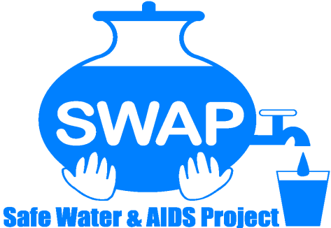

SAFE WATER AND AIDS PROJECT
ANNUAL REPORT 2024
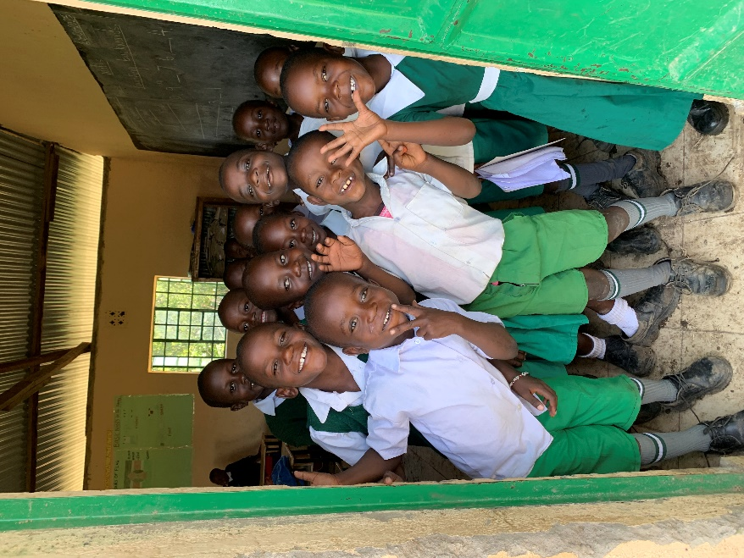

Contact:
Alex Mwaki – Country Director
E-mail: alex@swapkenya.org
Website: www.swapkenya.org
P.O. Box 3323-40100 Kisumu
Tel (+254) 20-2030712/ 714 761 268
Main office: Off Aga Khan Road,
Behind Royal City Garden Hotel, Milimani Estate, Kisumu, Kenya
Table of Contents
I. List of Acronyms 3
II. List of figures 4
III. From The Country Director’s Desk 5
IV. From The Technical Advisor Desk 6
V. SWAP’s Vision, Mission, and Core Values 7
VI. Acknowledgements 8
1.0. Summary of Progress and Achievements in 2024 9
2.0. Major Program activities 12
2.1. Orphans, Vulnerable Families Support 12
2.2. SWAP Model Centre 12
2.3. Donor See 14
2.4. Global Giving 14
2.5. Adopt a School Initiative 15
2.6. Flood Response 17
2.7. Community Scale Solar Water Treatment “Sola Maji 19
2.8. Rotary Sagam WASH Project 21
2.9. STREAM Chlorine Generation 21
3.0. Research Activities in 2024 22
3.1. Achieving Sustained Early Child Development Impacts at Scale 22
3.2. Development of Picture Comprehension 23
3.3. Monitoring morbidity, evaluation of new diagnostic tools, interventions to reduce or interrupt transmission and improving surveillance for intestinal schistosomiasis 23
3.4. Chronic Kidney Disease (CKD) at Jaramogi Oginga Odinga Teaching and Referral Hospital (JOOTRH) 24
4.0. Water Lab 26
5.0. Partnerships and Networks 28
6.0. Governance 29
7.0. Human Resources and Administration 30
8.0. Finance 31
9.0. Fund Management 33
10.0. Key challenges 33
11.0. Way Forward 33
12.0. Annex I – Publications 35
13.0. Annex II – SWAP organogram 43

List of Acronyms
ABHR Alcohol Based Hand Rub
ANC Ante Natal Care
ASGM Artisanal Small Scale Gold Mine
BMGF Bill and Melinda Gates Foundation
CBO Community Based Organization
CDC Centres for Diseases Control and Prevention
CHMT County Health Management Team
CHPs Community Health Promoters
CHVs Community Health Volunteers
CKD Chronic Kidney Disease
CoP Community of Practice
COVID-19 Coronavirus Disease 2019
ECD Early Childhood Development
ELISA Enzyme Linked Immunosorbent Assay
HCF Harber Charitable Foundation
HCF Health Care Facilities
HDSS Health Demographic Surveillance System
HPV Human Papilloma Virus
HENNET Health NGOs Network
IFRS International Financial Reporting Standards
IPC Infection Prevention and Control
JOOTRH Jaramogi Oginga Odinga Teaching and Referral Hospital
JOOUST Jaramogi Oginga Odinga University of Science and Technology
KASH Kemri Annual Scientific and Health Conference
KEBS Kenya Bureau of Standards
KEMRI Kenya Medical Research Institute
KES Kenya Shilling
KEWASNET Kenya Water and Sanitation Civil Society Network
KIWASCO Kisumu Water and Sewerage Company
LREB Lake Region Economic Bloc
MDA Mass Drug Administration
MIHIC. Maternal, Infant Health Insight and Cognitive intelligence
MNCH Maternal Neonatal and Child Health
MOH Ministry of Health
MOU Memorandum of understanding
NGO Non-Governmental Organization
NIH National Institute of Health
NHIF National Health Insurance Fund
NSSF National Social Security Fund
NTD Neglected Tropical Diseases
MUSERC Maseno University Scientific Ethics Review Committee
NACOSTI National Commission for Science, Technology, and Innovation
M&E Monitoring and Evaluation
OVC Orphans and vulnerable Children
PATH Program for Appropriate Technology in Health
PBO Public Benefit Organization
PLWD People Living with Disability
PCR Polymerase Chain Reaction
RCT Randomized Controlled Trial
SCHMT Sub County Health Management Teams
SHIF Social Health Insurance Fund
SOP Standard Operating Procedures
SWAP Safe Water and AIDS Project
SWE Safe Water Enterprises
TWG Technical Working Group
UC University of Colorado
UCB University of California Berkeley
UIC University of Illinois at Chicago
UNC University of Northern Carolina
US United States
USAID United States Agency for International Development
USC University of Southern California
USD United States Dollar
WASH Water Sanitation and Hygiene
WMF World Mathematics Fund
WSU Washington State University

List of figures
Figure 1 At the SWAP offices with some of the graduates of the OVC Program 12
Figure 2: Solar Powered Water Disinfection at SWAP Model Centre 13
Figure 3: Community and Medical Support 14
Figure 4: Liquid Soap packaging and labelling in SWAP’s lab. 15
Figure 5: Handwashing at Ombaka Primary using the Happy Tap 16
Figure 6: Launch of a Mathematics Resource Centre 17
Figure 7: Supporting families affected by flood at Ombaka Evacuation Camp 18
Figure 8: Supporting 50 families affected by flood at SWAP Model Centre in Ahero 19
Figure 9: The water tanks and water kiosks at Kopere 20
Figure 10: Joint inspection and supervision of work by Rotarians and Independent Assessor 21
Figure 11: Lab Manager test running STREAM Generators 21
Figure 12: SWAP Country director among panellists during the National childcare dialogue forum 22
Figure 13: Ultrasound performed by sonographer during the research field work 24
Figure 14: Donation of Alcohol Based Hand Rub to Nursing Staff at the Renal Unit of JOOTRH 25
Figure 16: Metal study field work at the Gold Mines 27
Figure 17: SWAP Income Analysis between 2020 and 2024 31
Figure 18: SWAP Expenditure Analysis between 2020 and 2024 32
Figure 19: SWAP expenses categories in 2024 32

From The Country Director’s Desk
It is my pleasure to share our 2024 annual report. The year started on a sound note with several contracts and partnerships established and strengthened. Safe Water & AIDS Project (SWAP) continued with its core mandate of implementing public health programs, research, and emergency response work. Key focus areas in the year were Water, sanitation and hygiene (WASH) including water quality monitoring, Early Childhood Development (ECD), Control and Elimination of Neglected Tropical Diseases (NTD) specifically schistosomiasis (bilharzia) and soil transmitted helminths, floods response, among others.
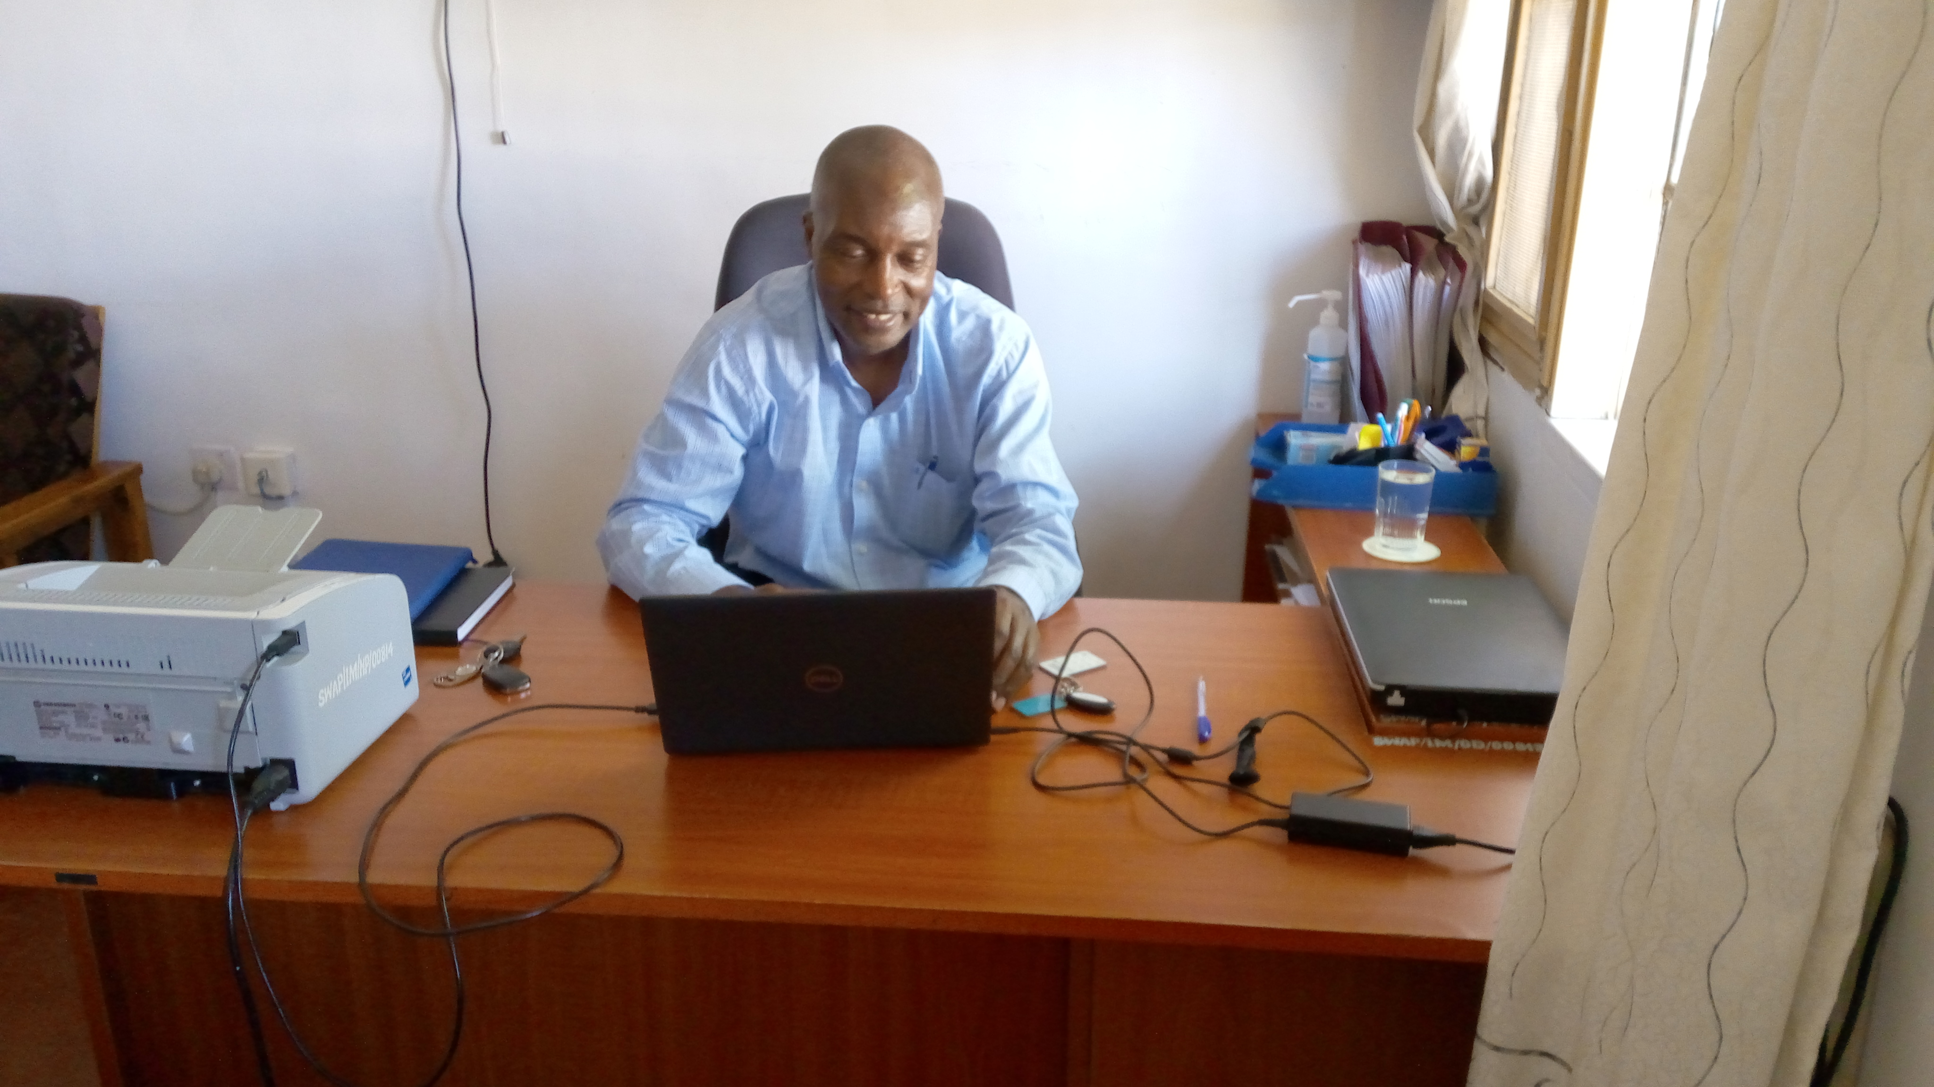

Despite increased taxation and high cost of living, SWAP achieved most of the deliverables and milestones set in the year. SWAP and Shemjen Engineering and Construction Limited signed a contract to construct the third community scale solar powered water “Sola Maji” project in Kopere, Kisumu County with funds from the Global Water Award of 2023. A sub-award contract was signed with Washington State University to install 4 STREAM chlorine generators in healthcare facilities of Migori County. The chlorine is used for infection prevention and control. A contract between SWAP and University of Southern California for year 3 was fully executed for a study on Early Childhood Development. A Framework Agreement with PharmAccess Foundation as fund manager for a project titled “Information Technology support to the PharmAccess Kenya Component of Connected Diagnostics” was fully executed. Suppliers on-boarding with Penn State University and University of California, Berkeley were completed. Previous contracts with University of Northern Carolina at Chapel Hill for fund management, the Board of Trustees of the University of Illinois at Chicago and Rotary Clubs of Oakland and Sagam were renewed. Sub agreement between the International Centre for Diarrheal Disease Research in Bangladesh and SWAP was signed for fund management covered under the Health Demographic Surveillance System (HDSS) project funded by the Gates Foundation through Emory Global Institute. Memorandum of Understanding between SWAP and Stanford University for the study titled: The Development of picture comprehension: improving learning materials and assessment tools in global context was fully executed. SWAP increased its visibility at national and global arena. The Eastern Africa Regional Early Childhood Development Conference took place between 11th to 14th March 2024 in Dar es Salaam, Tanzania. An ECD network Kenya meeting was held in Nairobi for the Council of Governors Secretariat as well a National Childcare Dialogue meeting. The Centres for Diseases Control and Prevention (CDC), in partnership with Washington State University (WSU) and SWAP hosted a side event at the UNC Water and Health Conference titled “Frontiers in WASH for outbreaks and beyond: Considerations for implementing programs in community gathering settings.” A poster presentation on our research on schistosomiasis and soil transmitted helminths was presented at the KEMRI annual scientific health conference in Nairobi
To the Board of Directors, SWAP employees, Collaborators, Partners, Funders, Beneficiaries and all readers and Friends of SWAP, we say a big THANK YOU!
Alex Mwaki – Country Director

From The Technical Advisor Desk
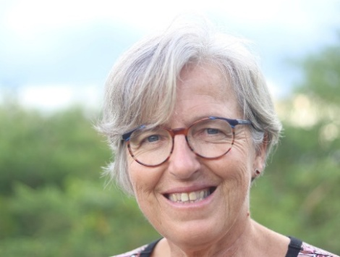
SWAP has completed 20 years of contributing to public health research, evidence-based programming, emergency response and community support in Western Kenya. It has been an amazing journey but not without unprecedented challenges in our mission to provide innovative solutions for improved health and economic status of communities.
Our dedication to this mission remains steadfast, driven by the resilience of communities that we witness every day. The diversified projects in this report are a testament to the unwavering support of our board of directors, donors, stakeholders, and staff. Their compassion, dedication, and generosity have been fundamental in advancing our mission. I must warmly thank everyone for going an extra mile and responding to the needs during good and turbulent times.
SWAP won several global awards. Our research continued to make significant positive impact to some of the most pressing global and local challenges. We contributed to seventy publications in peer reviewed international journals. We have provided advisory services, influenced policies, and continued with meaningful engagement with health, WASH, and research stakeholders. During 2024 we experienced massive flood and SWAP as always became one of the first responders supporting affected families and preventing disease outbreaks. Our laboratories have become learning hubs and major assets for water quality testing, disease surveillance, wastewater-based epidemiology and a production unit for Alcohol Based Hand Rub, Liquid Soap, and Chlorine. We are soon launching the third solar powered water disinfection unit providing safe water to marginalized communities. Through social marketing by community health promoters, we continued to increase access to thirty-five life-saving health products.
For the journey ahead, by August 2025, I will relocate to the Netherlands after 40 years providing public health services in Africa including 20 years at SWAP. It has been a rewarding journey with never dull moments. I will remotely still be involved and support SWAP where possible. As founder, I am enormously proud of all our achievements. Together, we have had a long-lasting impact on the lives of vulnerable communities, and we will continue in our efforts to create a brighter future and improve quality of their lives. Best wishes for 2025 with new opportunities full of blessings, peace and good health.
Alie Eleveld

Founder and Technical Advisor

SWAP’s Vision, Mission, and Core Values
Vision: A healthy and empowered community where everyone enjoys high quality life.
Mission: To provide innovative solutions for improved health and economic status of communities.
Core values:
- Dynamic: We progressively look back and use those experiences to determine our future direction.
- Resilient: We are resilient and adapt to positive and negative changes and needs in society.
- Integrity: We ensure integrity in staff, by having controls, systems, processes in place and practice zero tolerance to corruption.
- Efficiency: We strive for better results & high productivity in products and services, and excellent execution of our duties.
- Professionalism: We believe in maximizing the skills and expertise of our human resource in the delivery of health interventions and research, providing quality, efficient and effective services.
- Result Oriented: We strive to provide result-oriented health services, minimizing costs and maximizing outputs.
- Innovative: We are innovative, and change is our constant. We embrace the unknown and are willing to go the extra mile to achieve our goals.
- Diversity: We embrace diversity among staff, partners, and stakeholders. We always ensure there is a positive spirit which underpins the way we interact with others.

Communication
Facebook: www.facebook.com/Safe-Water-and-AIDS-Project-338690551549/?ref=hl
Website: Safe Water & AIDS Project
Instagram: @s.w.a.p_kenya
Crowd Funding Donor See: https://donorsee.com/swap
Crowd Funding Global Giving: https://www.globalgiving.org/projects/support-the-adopt-a-school-initiative-in-kenya/

Acknowledgements
SWAP’s achievements in 2024 would not have been possible without the unwavering support and generosity of our partners, donors, collaborators, and friends. To all those who contributed to our mission listed below, we extend our deepest gratitude.

- Centre for Diseases Control and Prevention
- University of Illinois at Chicago
- University of Southern California
- Kenya Medical Research Institute
- University of Durham
- Harber Charitable Foundation
- Gabriele Norado
- World Serve International
- Donor See
- Global Giving Foundation
- Washington State University
- Bill and Melinda Gates Foundation
- STEMA UK
- University of Leiden
- Maseno University
- Jaramogi Oginga Odinga University of Science and Technology
- Jaramogi Oginga Odinga Teaching and Referral Hospital
- University of North Carolina at Chapel Hill
- University of California, Berkeley
- Stanford University
- Thomas More University
- Aqua Research
- Tropical Institute for Community Health
- Innovations in Health Care
- Embassy of the Order of Malta
- World Mathematics Fund
- Aga Khan Foundation / Ismaili Community Kisumu
- University of Colorado
- Wild Geese Foundation
- National Commission for Science, Technology and Innovation
- Ilara Health
- SWAP Kenya.nl Foundation
- PharmAccess Foundation
- Siemens Stiftung
- Kenya Bureau of Standards
- Ujima Foundation
- Eden Park Foundation
- Lixil Corporation
- CARE Kenya
- Rotary Club of Sagam
- Ministry of Health/ Education/Water and other GOK departments
- KIWASCO
- ECD Network Kenya
- KEWASNET
- Lake Region Economic Bloc COVID-19
- International Centre for Diarrheal Diseases Research, Bangladesh

To all, your support has transformed lives, uplifted communities, and reinforced SWAP’s mission to provide innovative solutions for improved health and economic status of communities.

Summary of Progress and Achievements in 2024
Social Marketing and Distribution of Health Products
Social Marketing and door to door sales of thirty-six life-saving health products continued by trained community health promoters from Sabatia and Kegondi. Other sales are made by Ahero SWAP Model Centre, local markets, to health stakeholders and during exhibitions at Global Days events.

Support for Orphans and Vulnerable Families
Selected vulnerable orphans and youth supported by Harber Charitable Foundation and Gabriele Norado, a private well-wisher. Others have received long term scholarships through the Ya Juu Foundation with secondary and higher education. The main aim is to support them in their journey to become self-reliant and useful members of society.

SWAP Model Centre
An innovation centre where SWAP showcases best public health practices. These include solar powered water disinfection unit, health products promotion and sales, improved toilets with Sato Pan, kitchen with clean energy stoves and training centre.

Donor See
A crowdfunding platform which raises funds for vulnerable cases in the communities. This is ranging from school fees and requirements, income generating activities for widows, shelters, safe water innovations, medical emergencies, among others.

SWAP Foundation – The Netherlands
The SWAP Foundation was registered in the Netherlands on 31st August 2021. Main reason was to channel Donor See funds and have a platform for fundraising. The website address is: https://www.swapkenya.nl/ The board has three members, and the Technical Advisor is contact person in Kenya.

Global Giving
Global Giving is a crowdfunding platform. Currently SWAP is raising funds for one active project; the Adopt a School Initiative. Other projects related to the COVID-19 pandemic were closed.

Adopt a School Initiative
An initiative to support schools to comply with school health policies and guidelines by improving WASH infrastructure and provision of commodities in collaboration with the school board of management. It is helping schools in remote and under-served areas to improve the standards and provide a conducive learning environment.

Flood Response
SWAP is active member of the Western Kenya Humanitarian Hub and the Kisumu County Disaster Committee. The country experienced massive flood with yet again displacement of families affected, destroyed crops, infrastructure, and livelihood. SWAP became one of the responders in Nyando and Dunga with donations of food and non-food items, medical outreaches, and training of the local disaster committees.

Community Scale Solar water treatment: Sola Maji
Two sites in Ahero and Mugruk fully operational. Converts poor-quality surface water to drinking water that meets WHO and KEBS drinking water standards. All-solar, no groundwater depletion. Produces ozone for disinfection on-site using new micro-plasma technology. Third site in Kopere will soon to be launched.

Rotary Club of Sagam WASH Project
SWAP became independent assessor in a Rotary International funded project for WASH at Rawinji Primary School and St. Charles Kauko Primary School in Oyugis, Homa Bay County.

STREAM Chlorine Generation
SWAP supported training and the installation of two STREAM Chlorine Generators at Migori County Referral Hospital and Macalder Sub County Hospital. This was in collaboration with Washington State University and PATH.

Achieving Sustained Early Child Development Impacts at Scale
A 4-year NIH Funded study experimentally testing the relative effectiveness and cost-effectiveness of two different delivery models for an ECD responsive parenting intervention targeted to mothers and their children aged 6-18 months in a randomized adaptive trial. This study is in collaboration with University of Southern California and ECD Network Kenya.

Development of picture comprehension
This study was to investigate whether children’s understanding of pictures is related to children’s early experience with pictures and if learning materials and early cognitive assessment tools that involves pictures can help teachers, researchers, and policy makers. This study was done in collaboration with Stanford University targeting children between 3-9 years.

Monitoring morbidity, evaluation of new diagnostic tools, interventions to reduce or interrupt transmission and improving surveillance for intestinal schistosomiasis.
A five-years Cooperative Agreement with CDC from 2022-2027, focusing on bilharzia morbidity by ultrasound, surveillance and mapping, WASH in schools and monitoring Mass Drug Administration. A parasitology lab was established to analyse stool and urine samples.

Hospital Based Chronic Kidney Disease Study
A collaboration between the University of Illinois at Chicago, University of Colorado and JOOTRH Nephrology Department. The objective was to determine whether or not an epidemic of chronic kidney disease is occurring in Western Kenya, and if so, to identify environmental and occupational factors associated with the condition.

Water Lab
SWAP’s water lab has become an essential asset attracting lots of research partners evaluating WASH products, technologies, and interventions. The lab offers bacteriological water quality testing and full chemical analysis. It is a production unit for Alcohol Based Hand Rub, Liquid Soap, and Chlorine. It further supports disease surveillance and is a learning hub for local and international students.

Major Program activities

Orphans, Vulnerable Families Support
OVC program has been supported by the Harber Charitable Foundation (HCF) and Gabriele a private donor for a couple of years now. This initiative has been instrumental and has supported them accomplish their educational goals through payment of fees in high school and preschool level. Additionally, we supported upkeep and accommodation for those in college and business startup kitty as an exit strategy plan after completion of various training courses. Psychosocial therapy, counselling and career progression integrated into the program and is ongoing.
- Number of OVC supported with school fees were 15.
- Number of OVC graduated and received successful exit strategy were six out of which two received start up kitty to start income generating activities while they look for employment opportunities. One of the beneficiaries was retained at SWAP and offered an opportunity to work at the finance department.
- Five vulnerable families taking care of OVCs, people living with disability and an elder lady in the slums, were provided with routine basic supply every quarterly courtesy of Gabriele's fund kitty.
- Several individuals and vulnerable community members benefitted from school fees and requirements.
- Due to the harsh economic times, some desperate and vulnerable families were supported financially through settlement of hospital bills, funeral contributions, National Health Insurance P payments, Income Generating Activities, Shelter, food supplies and other forms of specialized needs.
- OVCs on full scholarship continue receiving financial support to complete their education.

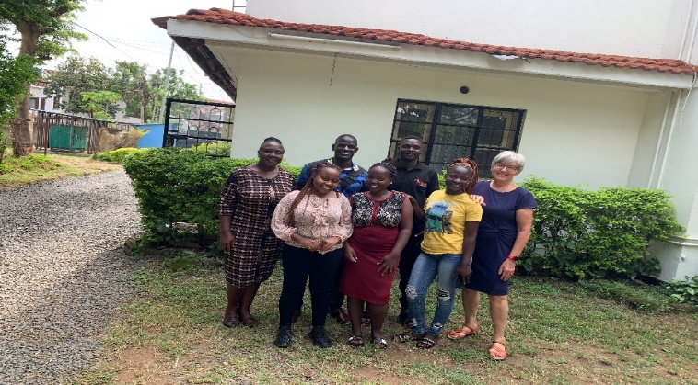
Figure 1 At the SWAP offices with some of the graduates of the OVC Program

SWAP Model Centre
SWAP model centre is situated in Ahero Town, Nyando Sub County. It was established in 2010 to showcase best public health practices. SWAP leased the land and introduced several innovations such as the solar powered water disinfection unit, also referred to as Sola Maji. It pumps water from river Nyando using solar power.
The apparatus converts the contaminated water to drinking quality water that meets the WHO and KEBS standards by using ozone for disinfection onsite via a new micro-plasma technology. The water is sold at market rates to individuals and water vendors. The trained water operator it the one managing the centre. Over time, the model has become a beehive of activities with international and regional visitors. Universities and colleges alike have been using the centre as a learning hub for their students.
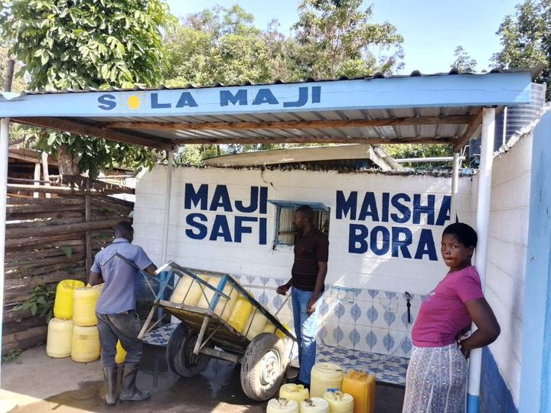
Another key initiative involves the social marketing and promotion of health products, which are distributed through a community kiosk. Revenue generated is reinvested into a revolving fund to ensure continuous stock replenishment. The implementation of new marketing strategies and promotional materials, supported by three students from the University of Leiden’s Frugal Innovation Course, significantly boosted sales of both water and health products.
Figure 2: Solar Powered Water Disinfection at SWAP Model Centre

The latrines were upgraded with the installation of Sato Pans, an innovative toilet pan featuring a mechanical and water seal that effectively blocks exposure to open air. This upgrade significantly reduces odours, minimizes fly infestations, and limits the spread of pathogens, enhancing overall sanitation and hygiene.
The centre features a traditional kitchen equipped with clean energy, improved cook-stoves. These cook-stoves not only reduce fuel consumption and environmental impact but also lower greenhouse gas emissions and help slow deforestation. Additionally, the reduced smoke production decreases the risk of upper respiratory tract and ocular infections caused by smoke exposure. Both the improved cook-stoves and the Sato Pan are actively promoted at the community kiosk to encourage wider adoption and improved public health in the communities it deserves.
A training room is used for community gatherings and trainings. Handwashing stations are strategically placed in the centre next to a ceramic filter for safe drinking water. The model centre was negatively affected by flooding after the river Nyando burst from its banks and submerged the centre with water and caused damages to the infrastructure.

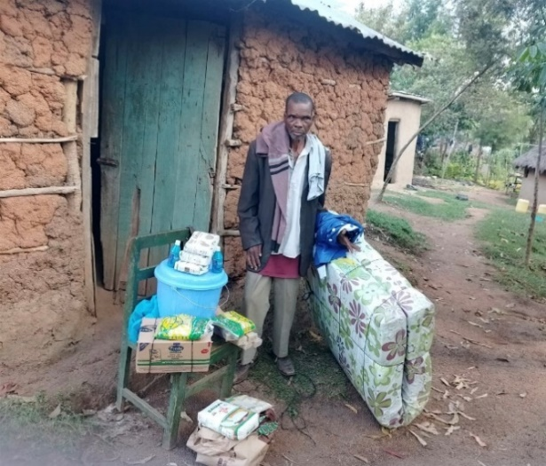
Donor See
Donor See is a United States (US) based crowdfunding platform that has enabled us to create meaningful impact and transformed lives in both big and small ways. Through this platform, we have successfully raised a cumulatively total of USD 37,637, fully funding 67 projects.

Figure 3: Community and Medical Support

In 2024 alone, we raised USD 13,154 and fully funded 10 projects as detailed below:
- We have brought clean safe drinking water to one entire village.
- We have provided two young individuals with the opportunity to pursue their education by paying school fees.
- We have offered medical care, wheelchairs, and physical therapy to four individuals.
- We have supplied lighting to one special school through solar installation.
- We have empowered five widows to start their own businesses, enabling them to support their families.
- We have supported families affected by floods and helped preventing disease outbreaks in one evacuation centre.
Additionally, 17 projects have received partial funding. All Donor See funds are channelled through the Dutch foundation SWAP Kenya.nl. Monthly transfers were done to our Euro account in Kenya to support vulnerable and marginalized families identified through Donor See. Your generous donations have made an enormous difference, and we look forward to your continued support in 2025. https://donorsee.com/swap

Global Giving
Global Giving is a US-based crowdfunding platform through which we have raised funds since 2016. To date, we have raised a total of USD 27,057, including USD 16,971 from donations and USD 10,086 through a grant for COVID-19 response. Once a threshold of USD 350 is met, funds are transferred to the SWAP Kenya Shilling account. The following projects have been uploaded to the platform:
- Sondu Water Enterprise – USD 9,967.46 was raised and project closed after target was met.
- COVID-19 grant - USD 10,086 was donated during the climax of the COVID -19 pandemic and was used to do COVID-19 vaccination outreach and social behavioural change communication.
- Help Protect Health workers – USD 5,734.79 was raised. The project was later deactivated due to its link to the COVID-19 pandemic and Global Giving no longer accepted funds for related initiatives.
- Liquid Soap Making – USD 870 was raised with USD 405 disbursed in January 2024 to buy additional ingredients for liquid soap production. Due to limited donations, the project was deactivated.
- Adopt a School Initiative –This is a new project that has been uploaded but no funds have been raised yet. However, several activities at schools still ongoing with other donor funds.

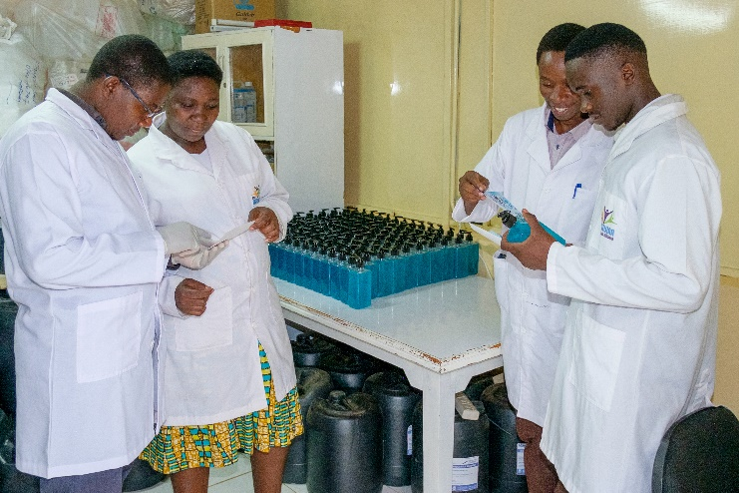
Figure 4: Liquid Soap packaging and labelling in SWAP’s lab.

Adopt a School Initiative
The adopt-a-school initiative was started during the COVID-19 pandemic to support schools during the COVID-19 pandemic to comply to COVID-19 rules and regulations. This initiative included improving WASH infrastructure and providing capacity building to help schools establish health clubs. Schools were selected from remote and underserved areas, and following assessments and consultations with the School Board of Management, priority areas were along with cost sharing plans.
Funding for the Adopt a School Initiative in 2024 was made possible through:
- Donor See – Feeding program, WASH Support at Ombaka Primary and solar installation at Ombaka Special School
- University of New England students and professors – Solar Installation at Ombaka Primary
- Aga Khan Council and Ismaili Community – During Eid celebration, SWAP was a guest of honour and donations were given both to Flood relief and to Adopt a School Initiative
- World Mathematics Fund – Mathematics Resource Centres (see schools listed below)
- Embassy of the Order of Malta – Construction of girls’ latrine and renovation of boys’ latrines at Ombaka Primary School.
Ombaka Primary School
Ombaka Primary School was one of the first schools to be adopted by SWAP under the Adopt a School Initiative. It is situated in a flood prone area in Nyando Sub County and on its compound is a designated evacuation camp.

The support given in 2024 includes:
- Ongoing food and WASH supplies such as handwashing stations, liquid soap, sanitary pads, and assorted food items for the feeding program.
- The ECD section received support with the provision of tables and chairs.
- Solar Installation which has had an enormous impact due to frequent electrical interruptions.
- Girls’ latrine constructions and renovation of boy’s latrine to meet the recommended ratio.

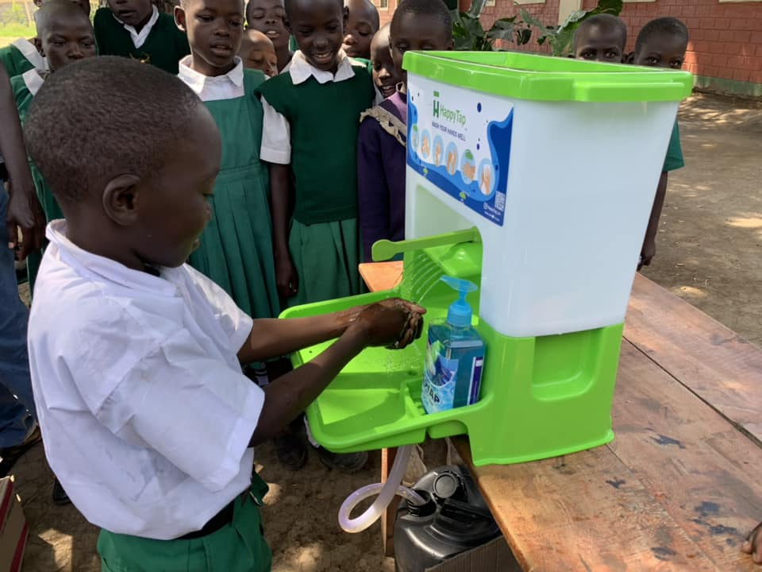
Ombaka Special School
This boarding school, located next to Ombaka Primary School, can accommodate 65 students with physical and mental challenges. SWAP provided the following:
- WASH supplies, food, and non-food assorted items.
- Solar Installation which provided essential support for boarders at night.

Figure 5: Handwashing at Ombaka Primary using the Happy Tap
Nyamasao Primary
Nyamasao Primary School is a neighbouring school to Ombaka Primary and has been very often
submerged by water due to back flow of the Lake Victoria and erratic weather.
Sanitary pad and liquid soap were donated.

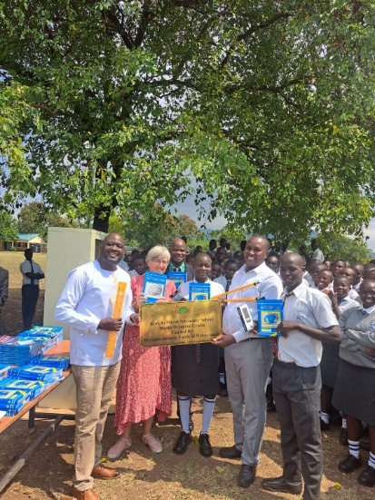
Mathematics Resource Centres
Several applications were submitted to support secondary schools in remote and underserved area with mathematics resources and teaching aids through funding from the World Mathematics Fund.
The beneficiaries included Koredo Mixed Secondary School in Homa Bay, Sihay Secondary and St Paul’s Jina in Siaya County. Additionally, a new application was submitted for Nyakwere Mixed in Suba Sub County, Homa Bay County, which is currently under review.

Figure 6: Launch of a Mathematics Resource Centre

Flood Response
SWAP is an active member of the Western Kenya Humanitarian Hub and the Kisumu County Disaster Committee, which unite humanitarian aid organizations and coordinate response during disease outbreaks and floods. From March to May 2024, we experienced severe flooding episodes in the majority of the country. At least 235 people died and more than 260,000 were displaced. Infrastructure was damaged, businesses were disrupted and significant revenue losses occurred. Furthermore, crops were destroyed and livestock perished. It posed serious health risks due to water contamination and contributed to psychological distress. The stagnant water became breeding site for mosquitoes which further increased the prevalence of malaria.

The area of SWAP’s operation experienced severe back flow from Lake Victoria. In December 2024, following erratic heavy rains, river Nyando burst its banks and the SWAP model Centre in Ahero and the surrounding villages were submerged by water.

Ombaka, in Nyando Sub County, has a designated evacuation camp located within the compound of Ombaka Primary School. During school closure, the classrooms serve as a temporary shelter for families affected by flood, while others use temporary shelters or integrate with host families. SWAP has always been one of the first responders during floods in the region. SWAP distributed food and WASH supplies to families affected to prevent disease outbreaks. We facilitated medical outreach and vaccination for families in the camps. Furthermore, we organized a training for the local disaster committee in Ombaka on climate resilience, to strengthen their capacity and ability to prepare for, to respond to, and to withstand the effects of climate change.

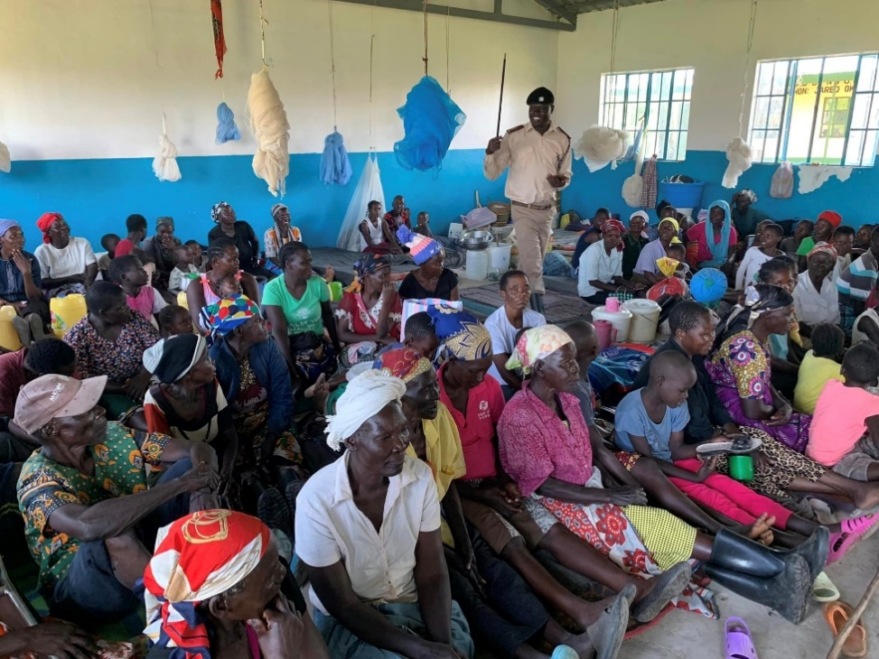

Figure 7: Supporting families affected by flood at Ombaka Evacuation Camp

In 2024, families displaced by flood received various services and supplies in Nyando and Kadibo Sub County, and in Dunga. The areas supported were:
- Ombaka evacuation camp, Ombaka Primary and Special School and Dispensary
- Ogenya evacuation camps
- At the SWAP Model Centre in Ahero we provided support for 50 affected families
- Nanga Primary School in Dunga which hosted displaced families
- Dunga Compassionate Centre for Families – a crisis centre in Dunga providing temporary shelter
- Chiela Women Group – a group of fishmongers in Dunga
- Kadibo Sub County – an assessment was done and report shared with the Kisumu County Disaster Committee for action.
- Medical outreach for treatment and Human Papilloma Virus and Malaria vaccination was done with support from Bunde Dispensary at Ombaka Dispensary.
- Training was organized for local disaster committee in Ombaka on climate change resilience and mitigation, WASH, and social behavioural change communication.

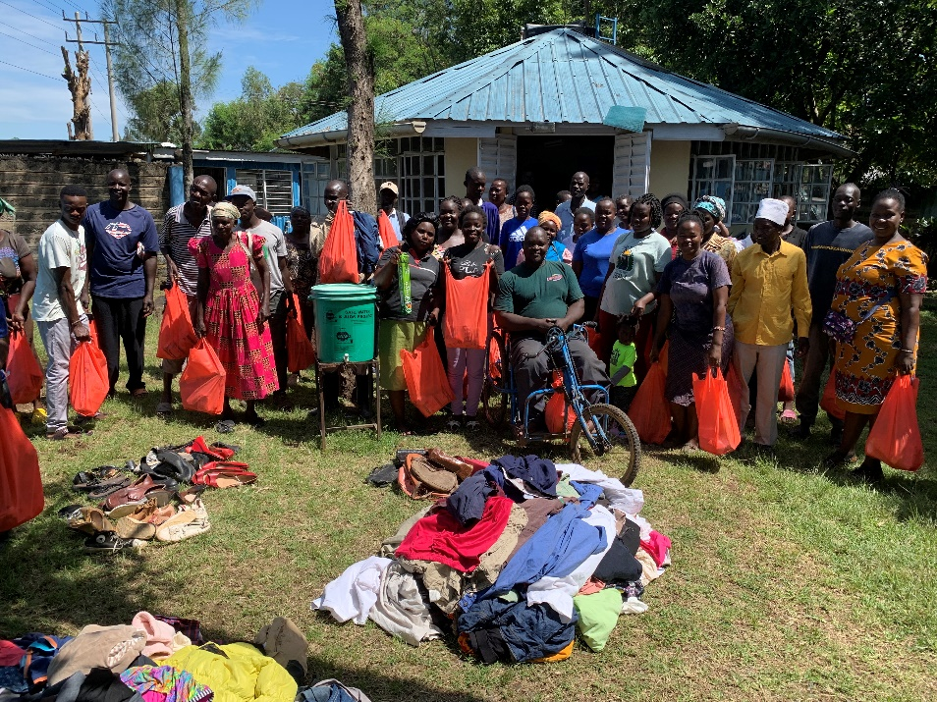

Figure 8: Supporting 50 families affected by flood at SWAP Model Centre in Ahero
Funding for flood response came from various sources. Several friends of SWAP provided cash donations and clothes after appeals for support were done on social media. Harber Charitable Foundation gave a one-time donation, along with contributions from private well-wishers through the SWAP foundation in the Netherlands. We were privileged to be supported during the Eid al Fitr Celebrations by the Aga Khan Foundation and Ismaili community, who invited SWAP for a presentation and donated funds and assorted items. An appeal for funds was also done through Donor See to mitigate the impact and prevent disease outbreaks during that period.

Community Scale Solar Water Treatment “Sola Maji
SWAP in collaboration with University of Illinois at Chicago, Eden Park Foundation and Shemjen Engineering and Construction, along with funding of the Global Water Award, renewed their partnership for the establishment of the third Sola Maji. Previous facilities were established in Ahero and Chutber, both of which are operational and providing safe, affordable drinking water to vulnerable communities.
SWAP and key stakeholders took a leading role in identifying a third site in the Muhuroni sub–County, Songo West sub-location for the establishment of the third Sola Maji. The stakeholders included the Kisumu County government, the Water department, local governmental officials and the registered community Ogen Water Service providers located in Kopere Township, who are also beneficiaries of Sola Maji 3. This third facility is targeting 2,500 households with direct inline ozone-treated water. This project integrates innovative lateral water filtration technology, solar-powered pumping and advanced water treatment technology, including inline water disinfection and aeration with ozone gas. Because the system is solar-powered, it produces no greenhouse gas emissions and ensures a reliable drinking water supply even during power outages.

The Sola Maji 3 description phases:
- Phase 1 - Water abstraction
This phase included the development of a 60 meter (m) well along the River Nyando. The abstraction process employs shallow lateral flows into the well's riverbank filtration to reduce or eliminate the need for alum dosing and reduce the pre-filtration energy footprint. A 3.2kW solar pumping array has been installed to pump 2000Lph water along 1500m pipeline to a 3m overhead 20,000L storage tanks at Ogen Secondary school.
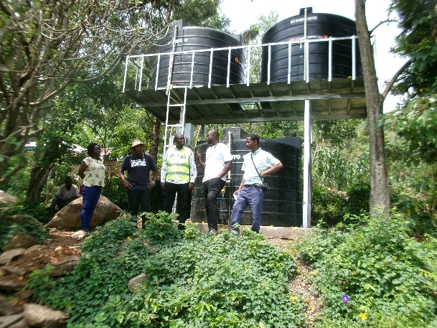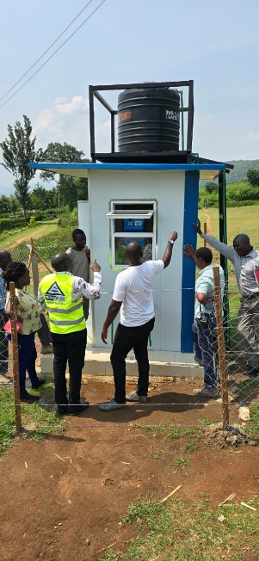

Figure 9: The water tanks and water kiosks at Kopere
- Phase 2 - Water disinfection and treatment
A series of self-cleaning filtration system, featuring 130micron to 90micron self-cleaning filters, has been provided to effectively remove the necessary silt before treatment.
A patented inline ozone water treatment system was also installed. This innovative technology, provided by Eden Park Foundation in collaboration with the University of Illinois at Urbana-Champaign, features a series of ozone generators injecting ozone gas directly into the water recirculation pipeline, ensuring effective treatment.
- Phase-3 - Distribution of treated water to consumers
We have provided a 1000m water distribution line the disinfection centre to Kopere market, supplying three water kiosks for vending the water to consumers.

The Kiosks are made of easy to assemble light weight panels for walling, combined with roofing insulation sheets. An integrated 50mm x 50mm x 2mm tank mounting structure temporary holds treated water into the vending machine. Also, the water supply extends to Ogen Primary and Secondary School, Ogen Health Centre, the Chairman’s residence, and the Kopere market police patrol camp.

Rotary Sagam WASH Project
SWAP signed a contract with Rotary Clubs of Sagam and Oakland as Independent Assessor for WASH project in Rawinji and St. Charles Kauko Primary Schools in Oyugis, Homabay County. Two contractors were engaged for borehole water works and sanitation works, respectively. By the end of the year, water works were 80% complete while sanitation works reached 90% completion. Some materials used for both water and sanitation works were of inferior quality, and contractors advised to replace them.
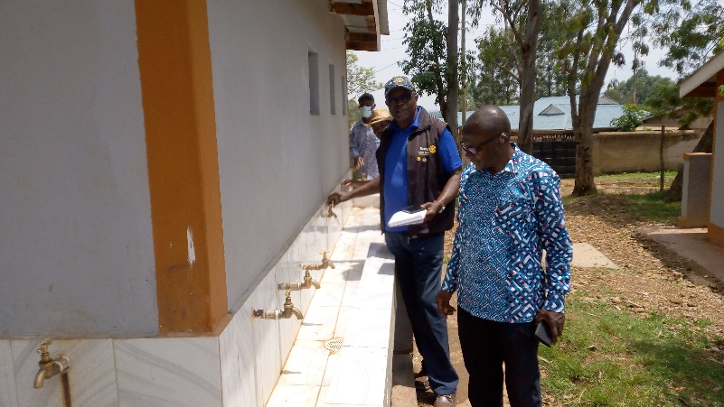
Figure 10: Joint inspection and supervision of work by Rotarians and Independent Assessor

STREAM Chlorine Generation
SWAP supported training and the installation of two STREAM Chlorine Generators at Migori County Referral Hospital and Macalder Sub County Hospital, in collaboration with Washington State University (WSU) and Program for Appropriate Technology in Health (PATH). STREAM Chlorine Generator continuously produces a Sodium Hypochlorite 0.5% solution using common salt and electricity. The chlorine-based solution generated by the STREAM complies with national and international guidelines for disinfecting surfaces, medical devices, and instruments. SWAP staff and WSU partners trained healthcare professionals at Migori Teaching and Referral Hospital and Macalder Sub-County Hospital. The training was based on how to use the STREAM chlorine generator and basic chlorine solution reconstitution. A tool was developed for monitoring the production and distribution.

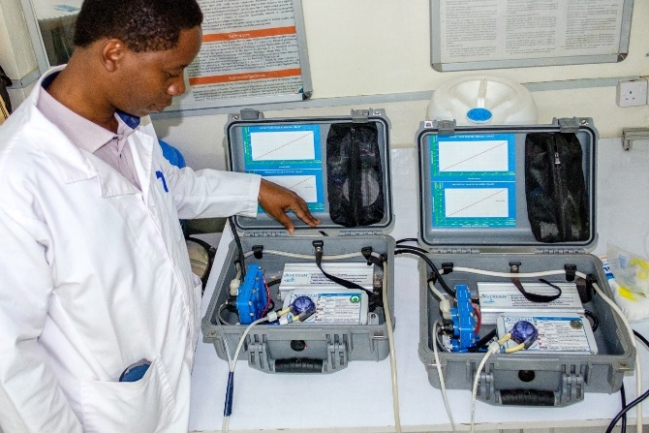

Figure 11: Lab Manager test running STREAM Generators

Research Activities in 2024

Achieving Sustained Early Child Development Impacts at Scale
The study aims to experimentally test the relative effectiveness and cost-effectiveness of two different delivery models for an ECD responsive parenting intervention targeted to mothers and their children aged 6-18 months in a randomized controlled trial. The study is implemented by three partners: SWAP, ECD network and the University of Southern California.
- Implementation targeting three sub- counties namely Kisumu West, Vihiga and Hamisi.
- Across sixty villages: 60 Community Health Promoters (CHPs) and their associated village randomly assigned to one of three treatment arms; in person, remote and control arms respectively.
- Arms 1 (in person) and 2 (remote) deliver the same content, which is based on the international curriculum tested in our earlier trial but extended over two years to maximize their potential to sustain impact.
- Baseline survey was done and results shared with counties in study areas.
- The project provided 324 smartphones and trainings to all households assigned to study Arm 2. Rigorous training for all CHPs was conducted on phone usage and ethical considerations, especially on child protection rights and safe use of social media applications. 37 CHPs and Mentors received a smartphone containing an open source locally available ECD App called “Survey CTO” for data collection and transmission to a central server. This lead to successful implementation of the intensive phase of the study and certificates to mothers and caregivers who participated were issued.
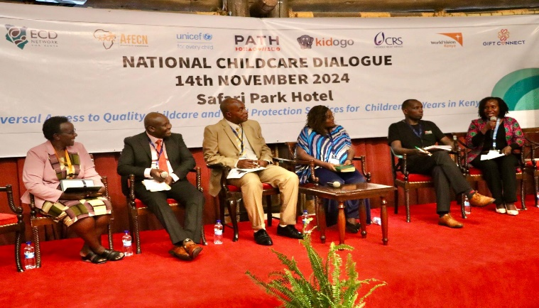
- Members of the ECD network for Kenya and partners were registered in the ECD study.

Figure 12: SWAP Country director among panellists during the National childcare dialogue forum
Stakeholder forums attended included the African Early Childhood Conference Network in Tanzania. The theme was “Investing in Early Childhood: Building Human Capital along the Life Course”. SWAP presented the Msingi bora ECD research. The Country Director was panellist in the national childcare dialogue meeting in Nairobi. SWAP continued to attend ECD network Webinars and virtual meetings as well as County stakeholder’s forums on ECD.

Development of Picture Comprehension
The aims of the study are to improve Learning Materials and Assessment Tools in Global Contexts and to investigate whether children’s understanding of pictures is related to children’s early experience with pictures. Conducted in Kisumu Central Sub County, the work was a collaboration between partners from the Kisumu County Health Management Team, Stanford University, SWAP, and the American Psychological Foundation. A total of 120 children aged between 4 - 9 years were enrolled and participated in the study. For the methodology, the study employed two key approaches: 1) Object versus Picture Assessment, where children were tasked with identifying objects, and 2) Creating Pictures, which involved asking children to draw objects.

Monitoring morbidity, evaluation of new diagnostic tools, interventions to reduce or interrupt transmission and improving surveillance for intestinal schistosomiasis
This five-year study is being conducted in four counties, namely Kisumu, Homa Bay, Migori, and Siaya. It targets pre-school children, school-aged children, and adults across 20 selected villages within these counties.

In October 2023, the study entered its second year, focusing on the first objective: creating a longitudinal cohort. Follow-up activities involved 999 adults enrolled in the first year, with 631 participants successfully tracked and 442 new participants enrolled.

During the year 2024, 367 participants tested positive for schistosomiasis and soil-transmitted helminths through microscopy, urinalysis, and ultrasound. These individuals were treated with praziquantel and albendazole. Additionally, 58 participants received treatment for malaria. A total of 1,073 ultrasound scans were conducted, and stool and urine samples were collected. Immunological assays were performed at the partner laboratory in Kenya Medical Research Institute (KEMRI), where Enzyme Linked Immunosorbent Assay (ELISA) standards typically sourced from CDC Atlanta were successfully developed as a notable achievement.

The study's contributions were shared at the KEMRI Annual Scientific and Health (KASH) Conference, where an abstract was presented, and staff actively participated. As part of Information, Education, and Communication (IEC) and advocacy efforts, community health promoters received training. T-shirts were distributed to community health promoters supporting the study, and handwashing stations were provided to participating schools. Furthermore, three new staff members were hired: two sonographers and a study administrator.

The study is now integrated into the Kisumu and Siaya Neglected Tropical Diseases Technical Working Groups, contributing to a comprehensive approach to the control and prevention of neglected tropical diseases. All study timelines and targets for the year were successfully achieved.

Figure 13: Ultrasound performed by sonographer during the research field work

Chronic Kidney Disease (CKD) at Jaramogi Oginga Odinga Teaching and Referral Hospital (JOOTRH)
A pilot study was conducted at Jaramogi Oginga Odinga Teaching and Referral Hospital (JOOTRH) by SWAP in collaboration with the University of Illinois at Chicago (UIC) and the University of Colorado (UC). The study aimed to generate knowledge about CKD at JOOTRH, providing insights into the overall disease burden and its complications in Western Kenya.
Specific Objectives:
- To describe the epidemiology of CKD at JOOTRH, the main public tertiary care hospital in Kisumu County, Kenya, by reviewing previously compiled reports summarizing the patient population with kidney injury and disease (2010–2024).
- To analyse medical records of 30 CKD patients, documenting details collected at the time of CKD diagnosis, including aetiology (or lack thereof) and clinical, biomarker, and sociodemographic data.
- To conduct a pilot study among 10 CKD patients undergoing dialysis at JOOTRH and administer a CKD questionnaire.
Methodology:
- Recruited, obtained consent, and conducted in-person interviews with 10 CKD patients (five men and five women), all aged 18 years or older and undergoing dialysis at JOOTRH.
- Reviewed administrative records and compiled reports maintained by the nephrology clinic at JOOTRH from 2014 to 2024 through retrospective data abstraction.
- Evaluated a data abstraction tool for collecting relevant information from JOOTRH’s medical records by examining a subset of records from 30 CKD patients.

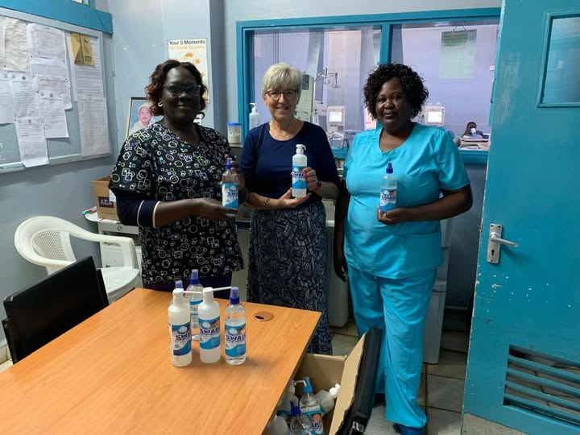
Figure 14: Donation of Alcohol Based Hand Rub to Nursing Staff at the Renal Unit of JOOTRH

Water Lab
The SWAP Water Lab “In 2024, the SWAP Water Lab remained a pivotal resource, supporting public health interventions, research, and WASH initiatives. Its capacity and expertise have attracted global, national, and regional research partners, contributing to several peer-reviewed publications. Through accreditation and strong collaborations, the lab has solidified its role as a leader in WASH standards, critical research, and community health initiatives. This comprehensive approach keeps SWAP at the forefront of sustainable health and environmental solutions.
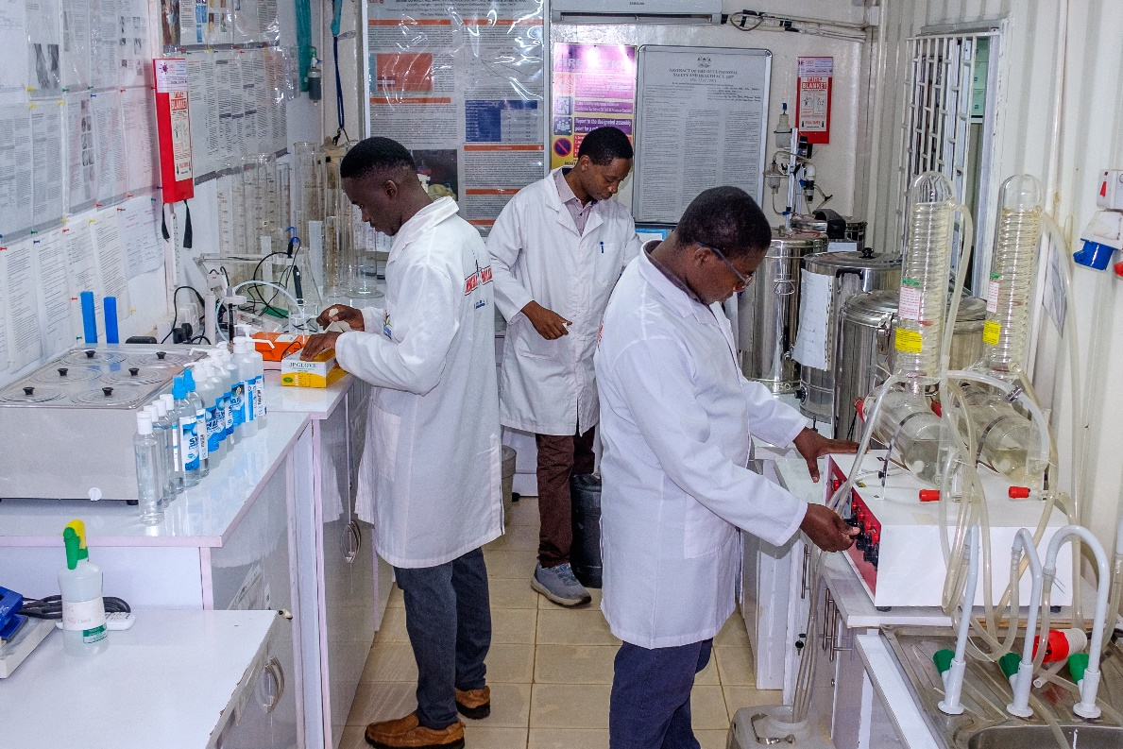
Figure 15: Water Lab staffs conducting various internal quality controls
Here is a non-exhaustive list of the lab’s activities:
Water Quality Testing
- Conducted bacteriological and chemical analyses to ensure compliance with WHO and KEBS standards for drinking water.
- Analysed water samples for organizations such as CARE Kenya, Siemens Stiftung, SANA International, Habitat for Humanity, private water suppliers and Tinderet Tea Factory.
Production of Essential Health Products
- Accredited by the Kenya Bureau of Standards (KEBS) to produce liquid soap and alcohol based hand rub.
- Supported infection prevention and control measures across various projects and studies through enhanced production efficiency.

Training and Capacity Building
- Conducted STREAM chlorine generator training for healthcare workers in Suna Sub County and Nyatike Sub County in collaboration with Washington State University, CDC, and the Migori County Health Department.
- Hosted workshops and training sessions for students, researchers, and community health assistants, fostering a skilled workforce in WASH and public health.
Research and Innovation
- Collaborated with the University of Illinois at Chicago School of Public Health (UIC SPH) to address health hazards in Artisanal and Small-Scale Gold Mining (ASGM). Samples were collected in Vihiga, Kakamega, Siaya, Busia, and Migori Counties to assess environmental and human health impacts.
- Partnered with Adili Solar Hub Takawiri, Siemens Stiftung, KEMRI, Nazava Filters, JOOUST, and Kisumu County’s Department of Health and Water to advance innovative water treatment solutions.
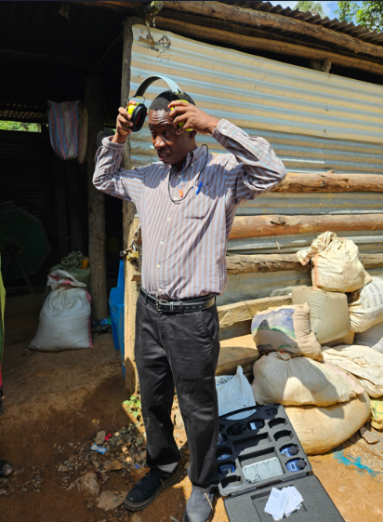
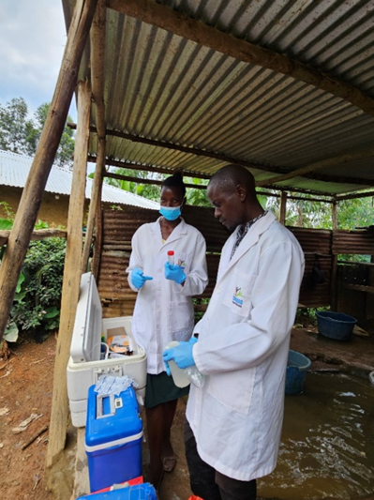
Figure 16: Metal study field work at the Gold Mines

Partnerships and Networks

New partnership opportunities in the period under review were with Stanford University for a picture comprehension study; PENN State University for a research proposal on female genital schistosomiasis; University of California, Berkeley for a study on Artificial Intelligence with Community Health Promoters; University of California, San Diego on water quality monitoring and International Centre for Diarrheal Disease Research in Bangladesh to evaluate data systems, identify challenges, and propose improvements for enhanced data quality and management within the HDSS framework. Weekly, monthly, and quarterly meetings cum webinars were convened and attended by our partners. The figure below shows a listing of new and ongoing partners at global, national, and regional levels.
Regional level:
- County & Sub County Health Management Teams
- Western Kenya Humanitarian Hub
- WASH Network
- TWG NTDs
- JOOUST
- MUSERC
- Rotary Clubs of Sagam and Oakland
- KEMRI
- PharmAccess Foundation

National level:
- NACOSTI
- Lixil Corporation
- Ilara Health Ltd
- KEWASNET
- HENNET
- ECDNeK
- WASH Sector Coordination
- Technical Working Group on WASH in Schools and Hygiene Promotion

Global level:
- CDC
- WASH in HCF CoP
- Decentralized chlorine use CoP
- UIC
- USC
- UNC at Chapel Hill
- Durham
- UC, Berkeley
- Stanford University
- UC, San Diego
- Penn State University
- WSU
- ICDDR, B
- Foundations
- Private Donors

Key Achievements in 2024
- Established six new meaningful partnerships across several areas of collaboration.
- Renewed collaborations with longstanding partners such as the University of Illinois at Chicago and Washington State University for ongoing studies and interventions.
- Hosted joint workshops and webinars, fostering knowledge exchange among health, WASH, and research professionals.
These strategic partnerships amplified SWAP's ability to achieve its mission and extended its influence across multiple sectors.

Governance

Governance
SWAP's governance structure ensures transparency, accountability, and effective decision-making, aligning with its mission to provide innovative solutions for improved health and economic status.
Board of Directors
- Comprises of Chair, Secretary, Treasurer, and five additional members with diverse professionals offering advisory services and policy oversight.
- Quarterly meetings are held, with the final meeting of the year serving as the Annual General Meeting (AGM).
- The Country Director serves as the Board Secretary, facilitating communication and compliance with governance protocols.
Management Team
- Consists of 11 senior employees heading various departments.
- Meets monthly to monitor compliance, oversee operations, and align activities with SWAP's strategic goals.
- Promotes quality assurance and operational excellence through adherence to organizational policies.
Compliance and Reporting
- SWAP aligns with the Public Benefit Organization (PBO) Act of Kenya, ensuring compliance with national regulations.
- Annual returns and audit reports are submitted during the first quarter of each year.
- Governance is guided by a comprehensive Governance Manual, fostering ethical practices and organizational integrity.
Key Updates in 2024
- The implementation of the new PBO Act required SWAP to register with the Public Benefit Organizations Regulatory Authority, strengthening its legal framework.
- Monthly narrative and financial reports were shared with the Board, enhancing oversight and accountability.
- A strategic focus was placed on developing a sustainable funding model and expanding partnerships.
SWAP's governance framework underscores its commitment to ethical leadership and accountability, driving impactful programs and sustainable growth.

Human Resources and Administration

The total number of staff increased from 40 to 53, with 13 new employees joining the team. These included two sonographers, one administrative assistant, one data analyst, eight research assistants, and one-night guard. Additionally, four students were placed on industrial attachment: two in procurement, one in the water lab, and one in the finance department. Four interns were engaged, including three international interns in various projects and one national intern in the Programs and Research department. The water lab welcomed one volunteer.

Key administrative changes included updates to the procurement committee's membership and the election of a new chairperson. The landlord introduced an agent to manage the premises.

The organization faced challenges due to the resignation of a Sonographer and the Finance Officer. The introduction of new financial obligations, including revised National Social Security Fund (NSSF) rates, a housing levy, and changes from National Health Insurance Fund (NHIF) to Social Health Insurance Fund (SHIF) with increased deductions, created additional strain. The lack of implementation of SHIF despite ongoing deductions further discouraged employees.

The SWAP welfare program supported staff experiencing bereavement and celebration of new births. Employees who have completed five years of service were recognized with certificates of long service. Several staff members enhanced their professional capacities through work-related specialization and online courses.

Finance

SWAP continued to be frugal and navigated its finances and operations in a disruptive environment impacted by turbulent external factors including floods, changes in government tax policy, currency fluctuations and high cost of living. We are proud in fulfilling our core mandate, and we remain thankful to our supporters including corporations, foundations, private donors and partners for entrusting us with resources to enhance community health. We remain focused on accountability, transparency and compliance to International Financial Report Standards. donor regulations and government statutory requirements.

Income in the year 2024 was KES 106,000,000.00 equivalents to USD 848,000. This was a 20% decrease in revenue as a result of projects being undertaken on a cost reimbursement basis with funds being received in subsequent months. The revenue distribution was as follows: Programs 25%, Research 50%, Emergency 5% and Administration 20 %. This represented an over expenditure against the total funds received as result of the cost reimbursement projects. Strengthening resource mobilization remain our topmost priority to ensure financial stability and sustainability.

Figure 17: SWAP Income Analysis between 2020 and 2024

Figure 18: SWAP Expenditure Analysis between 2020 and 2024

Figure 19: SWAP expenses categories in 2024

Fund Management

During the year, SWAP renewed contracts with three funding organizations including:
- Ilara Health Limited for the Validation of artificial intelligence developed Maternal, Infant Health Insight and Cognitive intelligence (MIHIC) scores for ante natal risk stratification in Kisumu County. The contract was extended through to June 2025.
- UNC at Chapel Hill for a research consultancy on Randomized Control Trial (RCT) to address unintended pregnancy rates in low resource settings. The contract was extended through April 2025.
- PharmAccess Foundation for Information Technological Support consultancy on Connected Diagnostics Digital Health Project. The contract was extended through July 2025.
One new fund management was established with International Centre for Diarrheal Diseases Research, Bangladesh funded by Gates Foundation through Emory Global Institute from July through December 2024 for the CHAMPS Health Demographic Surveillance Systems work in South Africa, Sierra Leone, Mali, and Nigeria by SWAP Monitoring and Evaluation (M&E) Coordinator.

Key challenges

- High cost of living following increase of prices for basic commodities and taxation
- Insecurity and petty theft in general due to inflation, poverty, and unemployment
- Weakening of the Kenyan Shilling
- Donor Funding not covering all salaries and operations, some staff members working on reduced level of effort
- Pre-financing and delay of payments from Donors causing cash flow issues
- Increase in fuel prices and product prices with reduced buying power from the community
- Erratic weather – El Nino and flooding

Way Forward

In 2025, we are looking forward to strengthening partnership with our loyal donors and bring new partners on board to diversify, have meaningful engagement and on the road to long term sustainability. Our membership will be renewed with the National ECD Network, Health NGO Network, Kenya Water and Sanitation Network, among others. We aim to remain relevant to an ever-changing environment. This will be done by embracing digital health, the latest technologies and ongoing capacity building of our employees. We hope to bring on board more scientists who can support grant writing for SWAP to implement and/or be fund manager. We are looking forward to receiving international students from University of Illinois at Chicago, University of Southern California, University of Montreal, and Thomas More University. Our water lab is an essential asset to attract more donors and partners for surveillance and support the preparedness for any future disease outbreaks, such as Mpox and cholera, just to name a few.
We will remain active in all the global and regional technical working groups and provide advisory services. We have more publications pending review in 2025 in international peer reviewed journals which will help increase our visibility and influence policies. We hope to launch the third solar powered water disinfection unit (Sola Maji) which will increase access to safe water to vulnerable communities.
The Technical Advisor and Founder of SWAP will relocate to the Netherlands but will be remotely involved and remain a board member of SWAP. However, there will be need to develop an exit strategy and preparation of the strategic plan for 2026 to 2028.

Annex I – Publications
2024
- Kowalcyk, M., & Dorevitch, S. (2024). A framework for evaluating local adaptive capacity to health impacts of climate change: Use of Kenya’s county-level integrated development plans. Annals of Global Health, 90(1), 15. https://doi.org/10.5334/aogh.4266
- Sam, O., Eleveld, A., Mbala, A., & Rogo, K. (2024). Enormity of Africa’s Mpox data: A comparative analysis. East African Medical Journal, 101(9). https://www.ajol.info/index.php/eamj/article/view/283184

2023
- Prentice-Mott, G., Odhiambo, A., Conners, E. E., Mwaki, A., Blackstock, A. J., Oremo, J., Akelo, O., Eleveld, A., Quick, R., Murphy, J., & Berendes, D. M. (2023). Evaluation of Sato pans as a new latrine technology in Kisumu County health care facilities, Kenya. Tropical Medicine & International Health. https://doi.org/10.1111/tmi.13939
- Zulaika, G., Nyothach, E., van Eijk, A. M., Wang, D., Opollo, V., Obor, D., Mason, L., Chen, T., Kerubo, E., Oyaro, B., Mwaki, A., Eleveld, A., Ngere, I., Fwaya, E., ter Kuile, F., Kwaro, D., & Phillips-Howard, P. A. (2023). Menstrual cups and cash transfer to reduce sexual and reproductive harm and school dropout in adolescent schoolgirls in western Kenya: A cluster randomised controlled trial. EClinicalMedicine. https://doi.org/10.1016/j.eclinm.2023.101764
- Hathaway, M. H., Patil, C. L., Odhiambo, A., Onyango, D., & Dorevitch, S. (2023). Prevalence and predictors of chronic kidney disease of undetermined causes (CKDu) in Western Kenya’s sugar belt: A cross-sectional study. BMC Nephrology, 24(1), 206. https://doi.org/10.1186/s12882-023-03213-2
- Solymari, D., Kairu, E., Czirjack, R., & Tarrossy, I. (2023). Caring interventions for the most vulnerable populations in economically disadvantaged areas during the coronavirus (COVID-19) pandemic by non-governmental organizations in Kenya. Social Sciences, 12(5), 248. https://doi.org/10.3390/socsci12050248

2022
- Berendes, D., Martinsen, A., Lozier, M., Rajasingham, A., Medley, A., Osborne, T., Trinies, V., Schweitzer, R., Prentice-Mott, G., Pratt, C., Murphy, J., ... Quick, R. (2022). Improving water, sanitation, and hygiene (WASH), with a focus on hand hygiene, globally for community mitigation of COVID-19. PLOS Water, 1(6), e0000027. https://doi.org/10.1371/journal.pwat.0000027
- Robbiati, C., Wood, C., Chelagat, W., Koskey, L., Mwai, G., Mwenja, I., Odhiambo, A., Bhatia, H., Ogden, E., Gutteridge, M., Peters, L. E. R., Tan, D., & Shannon, G. (2022). Building blocks of community positive health: the contribution of Kenyan communities. The Lancet Planetary Health, 6, S22. https://doi.org/10.1016/S2542-5196(22)00284-4

2021
- Luoto, J., Lopez Garcia, I., Aboud, F. E., Singla, D. R., Fernald, L. C. H., Pitchik, H. O., Saya, U. Y., Otieno, R., & Alu, E. (2021). Group-based parenting interventions to promote child development in rural Kenya: A multi-arm, cluster-randomised community effectiveness trial. The Lancet Global Health, 9(3), e315-e325. https://doi.org/10.1016/S2214-109X(20)30544-4
- Vanhuyse, F., Stirrup, O., Odhiambo, A., Palmer, T., Dickin, S., Skordis, J., Batura, N., Mwaki, A., & Copas, A. (2021). Effectiveness of conditional cash transfers (Afya credits incentive) to retain women in the continuum of care during pregnancy, birth, and the postnatal period in Kenya: A cluster randomized trial. BMJ Open, 11(9), e055921. https://doi.org/10.1136/bmjopen-2021-055921
- Powers, J. E., McMurry, C., Gannon, S., Drolet, A., Oremo, J., Klein, L., Crider, Y., Davis, J., & Pickering, A. J. (2021). Design and demand for a novel inline chlorine doser to increase water access. PLOS ONE, 16(1), e0245260. https://doi.org/10.1371/journal.pone.0245260
- Harvey, R. R., Luoto, J., Blackstock, A., Odhiambo, A., Oremo, J., Nygren, B., Fitzpatrick, M., & Quick, R. (2021). Impact Of Supply- and Demand-Side Interventions Integrated with Antenatal Care on Use of Maternal Health Services-Western Kenya, 2013‒2014. Journal of Health Care for the Poor and Underserved, 32(1), 338–353. https://doi.org/10.1353/hpu.2021.0027
- Straily, A., Malit, A. O., Wanja, D., Kavere, E. A., Kiplimo, R., Aera, R., Momanyi, C., Mwangi, S., Mukire, S., Souza, A. A., Wiegand, R. E., Montgomery, S. P., Secor, W. E., & Odiere, M. R. (2021). Use of a Tablet-Based System to Perform Abdominal Ultrasounds in a Field Investigation of Schistosomiasis-Related Morbidity in Western Kenya. The American journal of tropical medicine and hygiene, 104(3), 898–901. https://doi.org/10.4269/ajtmh.20-1175
- Straily, A., Kavere, E. A., Wanja, D., Wiegand, R. E., Montgomery, S. P., Mwaki, A., Eleveld, A., Secor, W. E., & Odiere, M. R. (2021). Evaluation of the Point-of-Care Circulating Cathodic Antigen Assay for Monitoring Mass Drug Administration in a Schistosoma mansoni Control Program in Western Kenya. The American journal of tropical medicine and hygiene, 106(1), 303–311. https://doi.org/10.4269/ajtmh.21-0599

2020
- Dorevitch, S., Anderson, K., Shrestha, A., Wright, D., Odhiambo, A., Oremo, J., & Heimler, I. (2020). Solar powered microplasma-generated ozone: Assessment of a novel point-of-use drinking water treatment method. International Journal of Environmental Research and Public Health, 17(6), 1858. https://doi.org/10.3390/ijerph17061858
- Kim, S., Curran, K., Deng, L., Odhiambo, A., Oremo, J., Otieno, R., Omore, R., Handzel, T., & Quick, R. (2020). Backpack use as an alternative water transport method in Kisumu, Kenya. Journal of Water, Sanitation and Hygiene for Development, 10(4), 986–995. doi: https://doi.org/10.2166/washdev.2020.239
- Hendrickson, C., Oremo, J., Akello, O. O., Bunde, S., Rayola, I., Akello, D., Akwiri, D., Park, S. J., & Dorevitch, S. (2020). Decentralized solar-powered drinking water ozonation in Western Kenya: An evaluation of disinfection efficacy. Gates Open Research, 4, 56. https://doi.org/10.12688/gatesopenres.13138.1
- Snyder, J. S., Prentice-Mott, G., Boera, C., Mwaki, A., Alexander, K. T., & Freeman, M. C. (2020). The Sustainability and Scalability of Private Sector Sanitation Delivery in Urban Informal Settlement Schools: A Mixed Methods Follow Up of a Randomized Trial in Nairobi, Kenya. International Journal of Environmental Research and Public Health, 17(15). https://doi.org/10.3390/ijerph17155298
- Murray, A. L., Napotnik, J. A., Rayner, J. S., Mendoza, A., Mitro, B., Norville, J., Faith, S. H., Eleveld, A., Jellison, K. L., & Lantagne, D. S. (2020). Evaluation of consistent use, barriers to use, and microbiological effectiveness of three prototype household water treatment technologies in Haiti, Kenya, and Nicaragua. Science of the Total Environment, 718. https://doi.org/10.1016/j.scitotenv.2019.134685
- Kim, S., Laughlin, M., Morris, J., Otieno, R., Odhiambo, A., Oremo, J., Graham, J., Hirai, M., Wells, E., Basler, C., Okello, A., Matanock, A., Eleveld, A., & Quick, R. (2020). Impact of community health promoters on awareness of a rural social marketing program, purchase and use of health products, and disease risk, Kenya, 2014–2016. Journal of Water, Sanitation and Hygiene for Development, 10(4), 940–950. https://doi.org/10.2166/washdev.2020.043

2019
- Zulaika, G., Kwaro, D., Nyothach, E., Wang, D., Zielinski-Gutierrez, E., Mason, L., Eleveld, A., Chen, T., Kerubo, E., van Eijk, A., Pace, C., Obor, D., Juma, J., Oyaro, B., Niessen, L., Bigogo, G., Ngere, I., Henry, C., Majiwa, M., et al. (2019). Menstrual cups and cash transfer to reduce sexual and reproductive harm and school dropout in adolescent schoolgirls: study protocol of a cluster-randomised controlled trial in western Kenya. BMC Public Health, 19. https://doi.org/10.1186/s12889-019-7594-3
- Meierhofer, R., Rubli, P., Oremo, J., & Odhiambo, A. (2019). Does activated silver reduce recontamination risks in the reservoirs of ceramic filters? Water, 11(5), 1108. https://doi.org/10.3390/w11051108
- Ochieng, C. A., & Odhiambo, A. S. (2019). Barriers to formal health care seeking during pregnancy, childbirth and postnatal period: A qualitative study in Siaya County in rural Kenya. BMC Pregnancy and Childbirth, 19, 339. https://doi.org/10.1186/s12884-019-2495-z
- Batura, N., Skordis, J., Palmer, T., Odhiambo, A., Copas, A., Vanhuyse, F., Dickin, S., Eleveld, A., Mwaki, A., Ochieng, C., & Haghparast-Bidgoli, H. (2019). Cost-effectiveness of conditional cash transfers to retain women in the continuum of care during pregnancy, birth and the postnatal period: Protocol for an economic evaluation of the Afya trial in Kenya. BMJ Open, 9, e032161. https://doi.org/10.1136/bmjopen-2019-032161
- Kim, S., Brown, A. C., Murphy, J., Oremo, J., Owuor, M., Ouda, R., Person, B., & Quick, R. (2019). Evaluation of the impact of antimicrobial hand towels on hand contamination with Escherichia coli among mothers in Kisumu County, Kenya, 2011-2012. Water research, 157, 564–571. https://doi.org/10.1016/j.watres.2019.03.085
- Ochieng, C. A., Haghparast-Bidgoli, H., Batura, N., Shannon, G., Copas, A., Palmer, T., Dickin, S., Noel, S., Fielding, M., Onyango, S., Odero, S., Eleveld, A., Mwaki, A., & Skordis, J. (2019). Conditional cash transfers to retain rural Kenyan women in the continuum of care during pregnancy, birth and the postnatal period: Protocol for a cluster randomized controlled trial. Trials, 20, 152. https://doi.org/10.1186/s13063-019-3224-8

- Shannon, G., Jansen, M., Williams, K., Cáceres, C., Motta, A., Odhiambo, A., Eleveld, A., & Mannell, J. (2019). Gender equality in science, medicine, and global health: where are we at and why does it matter? Lancet (London, England), 393(10171), 560–569. https://doi.org/10.1016/S0140-6736(18)33135-0

2018
- Curran, K. G., Wells, E., Crowe, S. J., Narra, R., Oremo, J., Boru, W., Githuku, J., Obonyo, M., De Cock, K. M., Montgomery, J. M., Makayotto, L., Langat, D., Lowther, S. A., O'Reilly, C., Gura, Z., & Kioko, J. (2018). Systems, supplies, and staff: A mixed methods study of health care workers’ experiences and health facility preparedness during a large national cholera outbreak, Kenya 2015. BMC Public Health, 18, 723. https://doi.org/10.1186/s12889-018-5584-5
- Alexander, K. T., Zulaika, G., Nyothach, E., Oduor, C., Mason, L., Obor, D., Eleveld, A., Laserson, K. F., & Phillips-Howard, P. A. (2018). Do water, sanitation and hygiene conditions in primary schools consistently support schoolgirls' menstrual needs? A longitudinal study in rural western Kenya. International Journal of Environmental Research and Public Health, 15(8), 1682. https://doi.org/10.3390/ijerph15081682

2017
- Freedman, M., Bennett, S. D., Rainey, R., Otieno, R., & Quick, R. (2017). Cost analysis of the implementation of portable handwashing and drinking water stations in rural Kenyan health facilities. Journal of Water, Sanitation and Hygiene for Development, 7(4), 659–664. https://doi.org/10.2166/washdev.2017.010
- LaCon, G., Schilling, K., Harris, J., Person, B., Owuor, M., Ogange, L., Faith, S., & Quick, R. (2017). Evaluation of student handwashing practices during a school-based hygiene program in rural western Kenya, 2007. International Quarterly of Community Health Education, 37(2), 121-128. https://doi.org/10.1177/0272684X17701263
- Fagerli, K., O’Connor, K., Kim, S., Kelley, M., Odhiambo, A., Faith, S., Otieno, R., Nygren, B., Kamb, M., & Quick, R. (2017). Impact of the integration of water treatment, hygiene, nutrition, and clean delivery interventions on maternal health service use. American Journal of Tropical Medicine and Hygiene, 96(5), 1253-1260. https://doi.org/10.4269/ajtmh.16-0709
- Fleming, E., Gaines, J., O’Connor, K., Ogutu, J., Atieno, N., Atieno, S., Kamb, M. L., & Quick, R. (2017). Can incentives reduce the barriers to use of antenatal care and delivery services in Kenya?: Results of a qualitative inquiry. Journal of Health Care for the Poor and Underserved, 28(1), 153–174. https://doi.org/10.1353/hpu.2017.0015

2016
- Phillips-Howard, P. A., Nyothach, E., ter Kuile, F. O., Omoto, J., Wang, D., Zeh, C., Onyango, C., Mason, L., Alexander, K. T., Odhiambo, F. O., Eleveld, A., Mohammed, A., van Eijk, A. M., Edwards, R. T., Vulule, J., Faragher, B., & Laserson, K. F. (2016). Menstrual cups and sanitary pads to reduce school attrition, and sexually transmitted and reproductive tract infections: a cluster randomised controlled feasibility study in rural Western Kenya. BMJ Open, 6(11). https://doi.org/10.1136/bmjopen-2016-013229
- Murphy, J. L., Ayers, T. L., Knee, J., Oremo, J., Odhiambo, A., Faith, S. H., Nyagol, R. O., Stauber, C. E., Lantagne, D. S., & Quick, R. E. (2016). Evaluating four measures of water quality in clay pots and plastic safe storage containers in Kenya. Water Research, 104, 312-319. https://doi.org/10.1016/j.watres.2016.08.022
- Pilishvili, T., Loo, J. D., Schrag, S., Stanistreet, D., Christensen, B., Yip, F., Nyagol, R., Quick, R., Sage, M., & Bruce, N. (2016). Effectiveness of Six Improved Cookstoves in Reducing Household Air Pollution and Their Acceptability in Rural Western Kenya. PloS one, 11(11), e0165529. https://doi.org/10.1371/journal.pone.0165529

2015
- Sahin, M., Mason, L., Laserson, K., Oruko, K., Nyothach, E., Alexander, K., Odhiambo, F., Eleveld, A., Isiye, E., Ngere, I., Omoto, J., Mohammed, A., Vulule, J., & Phillips-Howard, P. A. (2015). Adolescent schoolgirls’ experiences of menstrual cups and pads in rural western Kenya: A qualitative study. Waterlines, 34(1), 15-30. https://doi.org/10.3362/1756-3488.2015.003
- Slayton, R. B., Murphy, J. L., Morris, J., Faith, S. H., Oremo, J., Odhiambo, A., Ayers, T., Feinman, S. J., Brown, A. C., & Quick, R. E. (2016). A Cluster Randomized Controlled Evaluation of the Health Impact of a Novel Antimicrobial Hand Towel on the Health of Children Under 2 Years Old in Rural Communities in Nyanza Province, Kenya. The American Journal of Tropical Medicine and Hygiene, 94(2), 437–444. https://doi.org/10.4269/ajtmh.14-0566
- Bennett, S. D., Otieno, R., Ayers, T. L., Odhiambo, A., Faith, S. H., & Quick, R. (2015). Acceptability and use of portable drinking water and hand washing stations in health care facilities and their impact on patient hygiene practices, Western Kenya. PloS one, 10(5), e0126916. https://doi.org/10.1371/journal.pone.0126916

2014
- Alexander, K. T., Oduor, C., Nyothach, E., Laserson, K. F., Amek, N., Eleveld, A., Mason, L., Rheingans, R., Beynon, C., Mohammed, A., Ombok, M., Obor, D., Odhiambo, F., Quick, R., & Phillips-Howard, P. A. (2014). Water, sanitation and hygiene conditions in Kenyan rural schools: Are schools meeting the needs of menstruating girls? Water, 6(4), 1453-1466. https://doi.org/10.3390/w6051453
- Graves, J. M., Finsness, E. D., Quick, R., Harris, J. R., & Daniell, W. E. (2014). Teacher Perspectives on Implementing and Sustaining a Handwashing Promotion Intervention in Western Kenyan Primary Schools. International Quarterly of Community Health Education, 34(2), 159–170. https://doi.org/10.2190/IQ.34.2.d
2013
- Schilling, K., Person, B., Faith, S. H., Otieno, R., & Quick, R. (2013). Challenge of promoting interventions to prevent disease in impoverished populations in rural western Kenya. American Journal of Public Health, 103(12), 2131-2135. https://doi.org/10.2105/AJPH.2013.301459
- Fleming, E., Oremo, J., O'Connor, K., Odhiambo, A., Ye, T., Oswago, S., Zeh, C., Quick, R., & Kamb, M. L. (2013). The impact of integration of rapid syphilis testing during routine antenatal services in rural Kenya. Sexually Transmitted Diseases, 40(11), 664-669. https://doi.org/10.1155/2013/674584
- Person, B., Schilling, K., Owuor, M., Ogange, L., & Quick, R. (2013). A qualitative evaluation of hand drying practices among Kenyans. PLOS ONE, 8(9), e74370. https://doi.org/10.1371/journal.pone.0074370

2012
- Silk, B. J., Sadumah, I., Patel, M. K., Were, V., Person, B., Harris, J., Otieno, R., Nygren, B., Loo, J., Eleveld, A., Quick, R. E., & Cohen, A. L. (2012). A strategy to increase adoption of locally produced ceramic cook stoves in rural Kenyan households. BMC Public Health, 12, 359. https://doi.org/10.1186/1471-2458-12-359
- Patel, M. K., Harris, J. R., Juliao, P., Nygren, B., Were, V., Kola, S., Sadumah, I., Faith, S. H., Otieno, R., Obure, A., Hoekstra, R. M., & Quick, R. (2012). Impact of a hygiene curriculum and the installation of simple handwashing and drinking water stations in rural Kenyan primary schools on student health and hygiene practices. American Journal of Tropical Medicine and Hygiene, 87(4), 594-601. https://doi.org/10.4269/ajtmh.2012.11-0494
- Suchdev, P. S., Ruth, L. J., Woodruff, B. A., Mbakaya, C., Mandava, U., Flores-Ayala, R., Jefferds, M. E., & Quick, R. (2012). Selling Sprinkles micronutrient powder reduces anemia, iron deficiency, and vitamin A deficiency in Western Kenya: A cluster-randomized controlled trial. American Journal of Clinical Nutrition, 95(5), 1223-1230. https://doi.org/10.3945/ajcn.111.030072
- Briere, E. C., Ryman, T. K., Cartwright, E., Russo, E. T., Wannemuehler, K. A., Nygren, B. L., Kola, S., Sadumah, I., Ochieng, C., Watkins, M. L., & Quick, R. (2012). Impact of integration of hygiene kit distribution with routine immunizations on infant vaccine coverage and water treatment and handwashing practices of Kenyan mothers. Journal of Infectious Diseases, 205(Suppl 1), S56-S64. https://doi.org/10.1093/infdis/jir779
- Grant, F. K. E., Martorell, R., Flores-Ayala, R., Cole, C. R., Ruth, L. J., Ramakrishnan, U., & Suchdev, P. S. (2012). Comparison of indicators of iron deficiency in Kenyan children. The American Journal of Clinical Nutrition, 95(5), 1231–1237. https://doi.org/10.3945/ajcn.111.029900
- Harris, J. R., Patel, M. K., Juliao, P., Suchdev, P. S., Ruth, L. J., Were, V., Ochieng, C., Faith, S. H., Kola, S., Otieno, R., Sadumah, I., Obure, A., & Quick, R. (2012). Addressing inequities in access to health products through the use of social marketing, community mobilization, and local entrepreneurship in rural western Kenya. International Journal of Population Research, Article ID 470598. https://doi.org/10.1155/2012/470598
- Suchdev, P. S., Shah, A., Jefferds, M. E. D., Eleveld, A., Patel, M., Stein, A. D., Macdonald, B., & Ruth, L. (2012). Sustainability of market-based community distribution of Sprinkles in Western Kenya. Maternal & Child Nutrition, 9(1), 35-46. https://doi.org/10.1111/j.1740-8709.2012.00416.x
- Date, K., Person, B., Nygren, B., Were, V., Kola, S., Ayers, T., & Quick, R. (2012). Evaluation of a rapid cholera response activity — Nyanza Province, Kenya, 2008. Journal of Infectious Diseases, 205(Suppl 1), S62-S68. https://doi.org/10.1093/infdis/jis046
- Foote, E. M., Sullivan, K. M., Ruth, L. J., Oremo, J., Sadumah, I., Williams, T. N., & Suchdev, P. S. (2012). Determinants of anemia among preschool children in rural, western Kenya. American Journal of Tropical Medicine and Hygiene, 88(4), 757-764. https://doi.org/10.4269/ajtmh.12-0560
- Foote, E. M., Gieraltowski, L., Ayers, T., Sadumah, I., Faith, S. H., Silk, B. J., Cohen, A. L., Were, V., Hughes, J. M., & Quick, R. E. (2013). Impact of locally-produced, ceramic cookstoves on respiratory disease in children in rural western Kenya. The American Journal of Tropical Medicine and Hygiene, 88(1), 132–137. https://doi.org/10.4269/ajtmh.2012.12-0496
- Person, B., Owuor, M., Ogange, L., Jefferds, M. E., & Cohen, A. (2012). “It is good for my family’s health and cooks food in a way that my heart loves”: Qualitative findings and implications for scaling up improved cookstove interventions in rural Kenya. International Journal of Environmental Research and Public Health, 9(5), 1566-1580. https://doi.org/10.3390/ijerph9051566
- Ryman, T. K., Briere, E. C., Cartwright, E., Schlanger, K., Wannemuehler, K. A., Russo, E. T., Kola, S., Sadumah, I., Nygren, B. L., Ochieng, C., Quick, R., & Watkins, M. L. (2012). Integration of routine vaccination and hygiene interventions: A comparison of 2 strategies in Kenya. The Journal of Infectious Diseases, 205(Suppl 1), S65–S76. https://doi.org/10.1093/infdis/jir777
- Graves, J. M., Daniell, W. E., Harris, J. R., Obure, A. F. X. O., & Quick, R. (2012). Enhancing a Safe Water Intervention with Student-Created Visual AIDS to Promote Handwashing Behavior in Kenyan Primary Schools. International Quarterly of Community Health Education, 32(4), 307–323. https://doi.org/10.2190/IQ.32.4.d

2011
- Loewenberg, S. (2011). Fighting child malnutrition in Africa through the use of micronutrient supplements. Health Affairs, 30(6), 1160-1164. https://doi.org/10.1377/hlthaff.2010.1138

2010
- Jefferds, M. E., Ogange, L., Owuor, M., Cruz, K., Person, B., Obure, A., & Suchdev, P. S. (2010). Formative research exploring acceptability, utilization, and promotion in order to develop a micronutrient powder (Sprinkles) intervention among Luo families in Western Kenya. Food and Nutrition Bulletin, 31(Suppl), S179-S185. https://doi.org/10.1177/15648265100312S210

2009
- Freeman, M. C., Quick, R. E., Abbott, D. P., Ogutu, P., & Rheingans, R. (2009). Increasing equity of access to point-of-use water treatment products through social marketing and entrepreneurship: A case study in Western Kenya. Journal of Water and Health, 7(3), 527-534. https://doi.org/10.2166/wh.2009.063
- Harris, J. R., Greene, S. K., Thomas, T. K., Ndivo, R., Okanda, J., Masaba, R., Nyangau, I., Thigpen, M. C., Hoekstra, R. M., & Quick, R. E. (2009). Effect of point-of-use water treatment and safe water storage interventions on diarrhea in infants of HIV-infected mothers. Journal of Infectious Diseases, 200(8), 1186-1193. https://doi.org/10.1086/605841

2007
- Centers for Disease Control and Prevention (CDC). (2007). Baseline data from the Nyando Integrated Child Health and Education Project — Western Kenya, 2007. Morbidity and Mortality Weekly Report, 56(42), 1109-1113.

Annex II – SWAP organogram
